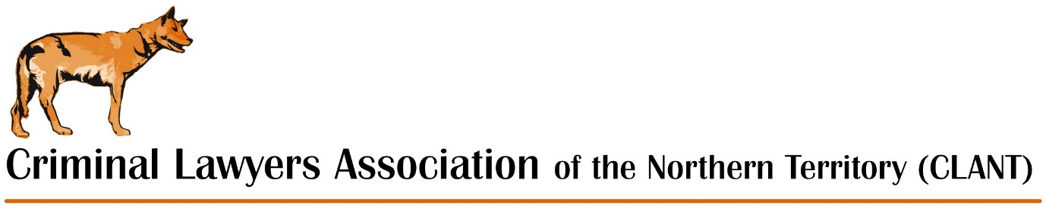

Form of proxy
I,________________________________________________________
(print name)
Being a current financial member of the CRIMINAL LAWYERS
ASSOCIATION OF THE NT, hereby appoint:

____________________________________________________________
(print name)
Also a current financial member of the CRIMINAL LAWYERS
ASSOCIATION OF THE NT to vote on my behalf at the 2023 AGM on
Thursday 30 November 2023.

I declare that having given my proxy as set out above I will not
Vote at the AGM on Thursday 30 November 2023.

Signed:______________________________________________________
(signature of member)
Date:________________________________________________________

