CRIMINAL LAWYERS ASSOCIATION
of the Northern Territory (CLANT)

NINETEENTH BIENNIAL CONFERENCE

TOUGH SOFT SMART ON CRIME

THE TRIAL OF ANNE BOLEYN
How Annie lost her head to Hal

A play reading presented by the CLANT players

SATURDAY 22 JUNE – FRIDAY 28 JUNE 2024 HYATT REGENCY
SANUR, BALI

INTRODUCTION

THE TRIAL OF ANNE BOLEYN

INTRODUCTION
This introduction is again based on that included with previous play readings presented to the CLANT Conferences. Previous attendees and aficionados of this segment of the conferences may be forgiven if they do not find it necessary to be reminded of what follows. They might like to skip to the sub-heading How Anne Boleyn lost her head to Hal below.

This is the fifteenth in a series of play readings presented to the CLANT Bali Conference by the CLANT Players.* The first was presented at the 5th Conference at the Bali Hyatt in Sanur in 1995. As usual, the purpose of the play is to entertain and amuse, but also to say something about the abuses of and by the criminal law, now and in history. In writing this year’s piece, as ever, it occurred to me that there are certain common threads which have run through the particular plays chosen.
We can discard two of the presentations from this consideration. In 2007, we presented John Mortimer’s Dock Brief. It did expose, in a very quirky way, a deficiency in the English Law, while both amusing and entertaining the delegates, but the forensic advantage gained – fictionally – was to the accused; no harm done! In 2009, we presented a series of vignettes, Serving it up in Court. All were said to be true stories from courts, but they were shamelessly aimed at getting some laughs from the delegates and other members of the audience.

Otherwise, the common threads all point to unfair trials of one kind or another. The accused in Ned Kelly [1997], Tuckiar [1999] and Bentley [2003] were all charged with the murder of policemen. Judges and jurors seem to act under particular constraints in these cases. An acquittal would be most unlikely. In the Popish Plot trials of 1684 [CLANT, 1995], the allegation was that an assassination attempt against the life of the King was to be made. Roman Catholic priests were involved. They were then an unprotected class! The prosecutor Jeffreys [later known as the hanging judge] behaved abominably, as did the Chief Justice and the perjured witnesses. They were all looking for preferment under the political regime at the time. In these four cases, only Tuckiar survived his sentence of death [although query whether some certain steps were taken…he never made

it back to Arnhem Land]. Legal representation was poor, or non-existent, in all these trials.
The Eureka Trials [2001] sprang from a government determined to assert itself against the rebelling miners. This is the only one of our series of play reading cases where outright acquittals were obtained at trial. The members of the jury, representing the community, were not prepared to accept an unfair and repressive political system.

Rupert Maxwell Stuart [CLANT, 2005] was an Aboriginal man accused of raping and killing a girl. Community feeling ran high, as it did in the 1921 case of Colin Ross [CLANT, 2013] in Victoria. He was charged with a similar offence, although he did not suffer from any racial prejudice. He was executed; Stuart was not. Both, however, were prosecuted equally vigorously and their trials demonstrate injustices.

Other presentations included The Shearer’s Tale [the NSW trial of McDermott In 1948]. He was later acquitted posthumously of the murder, 50 years or more after the event. Fortunately, he was not executed and was released early from prison. It was only after the body of his supposed victim was found many years afterwards that his innocence was established. Lindy Chamberlain’s case was represented for CLANT by the second inquest into the death of Azaria. That, to this chronicler, was a grossly unfair proceeding. Her innocence was not finally confirmed authoritatively until the fourth inquest, held in 2012.
In 2017, the CLANT Playreaders performed the Victorian 1950 trial[s] of John Bernard Kerr for murder of a young woman. He was convicted on the basis of alleged confessions made by him to one Bluey Adam. These were challenged at the time, but unsuccessfully. Nevertheless, Kerr only served 12 years and had a reasonably long private life thereafter, always protesting his innocence.

It was noted in that play’s introduction that trials were dealt with much more expeditiously in earlier times. The victim in this matter died on 28 December 1949. By December 1950, there had been a committal, three trials [the first two juries couldn’t agree], two visits to the CCA, one to the Privy Council, and a commutation of the death sentence by Cabinet. Things moved swiftly!
The trial of Marie Antoinette was an intriguing one. It was presented at the CLANT Conference in Bali in 2019. As in the 2017 play reading, a new style of presentation was adopted with the words being written in verse – rhyming

couplets – and there was musical accompaniment. These were hardly Shakespearean in quality, and were introduced mainly to satisfy the writer’s ego, but apparently were enjoyed by the delegates and friends.

The trial itself was conducted in 1793, as part of the excesses of the French Revolution. It demonstrates many of the unfortunate aspects of the earlier trials presented in the play readings – oppressive prosecutors and judicial officers and a public loathing and fuelled abhorrence of the accused person. Legal representation was inadequate [particularly in respect of the time made available] and witnesses perjured themselves. The trial was a complete travesty and led to the guillotine within 52 hours of its commencement. There was much amusement at the style of presentation – with ‘allo! ‘allo! English/French – but there was no denying the poignancy of the play’s dénouement.

In 2022, in the Darwin version of the Bali conference, the players presented The Trial of Andrew Ballard [NOT]. Mallard had been convicted of the murder of a shopkeeper in a Perth WA suburb. He served 12 years before being released. This was the result of intense support for him and was followed by an inquiry by the WA Crime and Corruption Commission, into the conduct of his original police investigation and prosecution. Mallard’s case had been up and down to the High Court twice, before the successful appeal in respect of a Petition for Clemency which had been rejected by the Court of Criminal Appeal. The major issue on which the appeal succeeded was the non-disclosure to the defence of important forensic and other material. When the dust had settled, it seemed that another prisoner in the WA system had been the real killer. Mallard got significant compensation, but unfortunately died early. He was struck by a hit-and–run driver in California.

HOW ANNE BOLEYN LOST HER HEAD TO HAL
Henry VIII is the best-known of English monarchs, largely because he had six wives. This unrivalled record was partly due to his character, but also to political demands and the chance circumstances, such as the need to produce healthy boys. For all Henry’s efforts, only three legitimate children survived him, only one of them a boy, and a sickly youth at that. Each of these three did ascend the throne, with Elizabeth I arguably the greatest of all England’s monarchs. This rather rendered Henry’s efforts to father a son, a waste of time (and lives!).

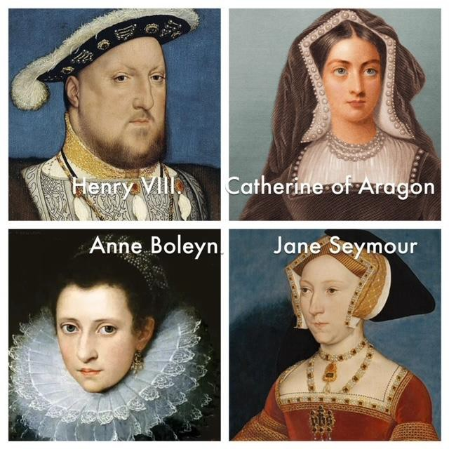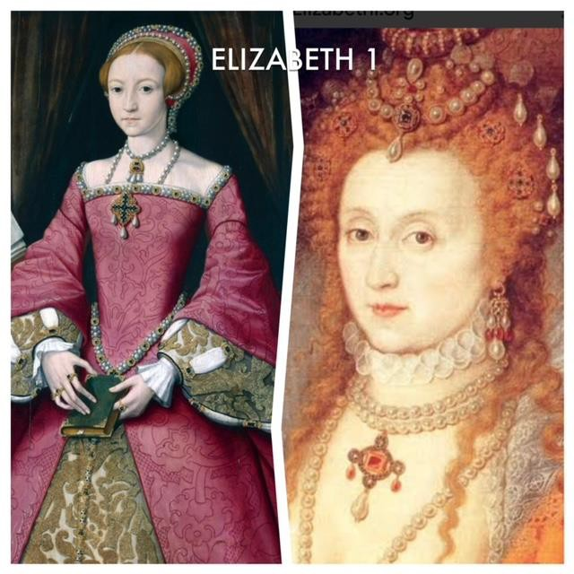
Henry Tudor was born in 1491, the second son of Henry VII. He was handsome, intelligent and athletic – much of these good qualities being lost in later years. His older brother, Arthur, died young, and on Henry VII’s death in 1509, Henry ascended the throne. He married Catherine of Aragon shortly after ascending the throne, shortly before his coronation in June 1509. He was not quite 18. Catherine was then aged 23, the widow of his brother Arthur, and there were no children of that marriage. At issue later was the question whether the marriage had been consummated. They had been married in 1501. Arthur was then only 14 and he died, aged 15, on 2 April 1502. Catherine was only 16. She was later to swear that the marriage was not consummated.

Although Catherine conceived 8 times, the only surviving child was Mary, born in 1516 (Queen Mary I, 1553-1558). By 1525, it was obvious that she would not produce a male heir. The refusal by Pope Clement VII to grant an annulment of that marriage set in train the events leading to the Reformation. Henry exploited widespread anticlericalism to end the authority of the Pope and place himself at the head of the English Church. This was accomplished in1532-1536 through a series of momentous Acts of Parliament, with the guidance of Henry’s principal adviser, Thomas Cromwell. Cardinal Wolsey had refused to provide an annulment of Henry’s marriage to Catherine. He was sacked, and replaced by Cromwell, whom he had mentored.

For some years, Henry sought to rid himself of the marriage, so that he could marry Anne Boleyn, with whom he was infatuated. He had previously installed, amongst others, her sister Mary Boleyn as his mistress, but he apparently preferred Anne’s charms. Anne would not yield to the King, until it seemed that nothing could hasten the annulment. She surrendered to him, became

pregnant, thus forcing his hand, and they married secretly on 25 January 1533. Elizabeth was born on 7 September 1533 (Queen Elizabeth I, 1558-1603).
Shortly after, Henry obtained his Annulment of marriage from Catherine, through the good offices of the Archbishop of Canterbury Thomas Cranmer, assisted by Cromwell’s intervention.
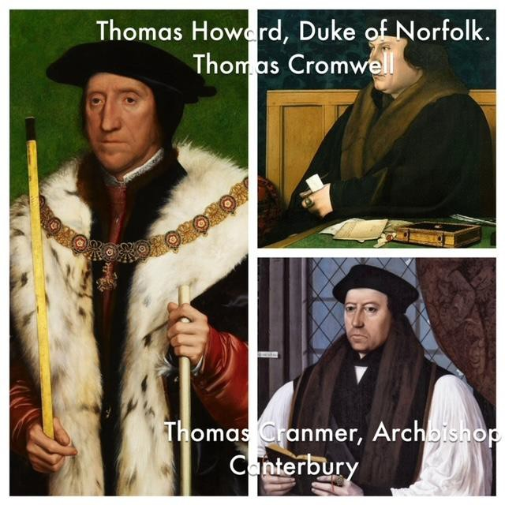

Besides Elizabeth, Anne had two still-born children and one miscarriage. Failure to produce a male child and accusations of adultery were to lead to her execution. The allegations against her probably arose from foolish flirtations in her Court. They were made the subject of intense investigation and surveillance by agents of Cromwell, acting on behalf of the King, who was now anxious to rid himself of Wife No 2. These machinations, and the trial that followed, will be the subject of the play reading.

It would be easy to look at the way in which the trial was prepared and conducted and say it was unfair. Looking at it from modern perspectives, it is clearly not in accordance with current principles. But in the 16th Century, counsel were not allowed in any treason cases, and cases proceeded generally without oral witnesses. Statements were read and the accused invited to respond and disprove them – but without the capacity to call witnesses in reply. In many cases they would not know the specificity of the allegations against them until made in the court. Of course, to the extent that witnesses were suborned or tortured – either as witnesses or accused – to make confessions, there can be no excuse. Whether this occurred in Anne’s case we will never know.

There were nine new statutes in the time of Henry VIII creating new treasons. Four were directed at asserting and maintaining the position of opposition taken by the King to the Pope. Five were aimed at maintaining the succession of the crown as it changed with each new marriage. The Act passed in 1534, after his marriage to Anne, made it treason, inter alia:-
(1) Maliciously to wish, will, or desire by words or writing, or by any craft to imagine, invent, practise, or attempt any bodily harm to the king, queen, or their heirs apparent.

The prosecutors managed to fit Anne’s dealings with her courtiers within this
framework.

As to the proceedings at trial, nothing exists except a formal record of the verdict. The indictment alleges that Anne committed adultery with five specified persons on five separate occasions, with time and place specified. The abstract from the indictment, states the Queen –

Did falsely and traitorously procure, by means of indecent language, gifts and other acts therein stated, divers of the King’s doctors and familiar servants to become her adulterers.

I cannot leave these considerations without drawing attention to the Act passed in 1542 [33 Hen.8, c.21], after the execution of Catherine Howard for traitorous adultery. This act made it treason in any woman -

whom the king shall intend to take to wife thinking her a pure and clean maid, if she be “not so”, to marry the king without discovering it to him before marriage, and in any one knowing the fact not to reveal it to the king or one of his council.

As soon as Henry was dead, this horrible piece of legislation was repealed.

The legislation was described by Stephen in his History of the Criminal Law of England, as an unqualified disgrace to (Henry’s) memory [Vol II, 259]
It brings me to my next observation. The behaviour of Henry throughout these years bears all the hallmarks of domestic violence of the worst kind – albeit, without any known physical belligerence applied directly to his partners by the King.

Waiting in the wings [almost literally] was Jane Seymour. Following Anne’s execution, Henry married Jane on 30 May 1536. Like Anne before her, she had earlier served as a lady-in-waiting in Catherine’s Court. She had also been in attendance at Anne’s Court. Jane gave birth to Edward (Edward VI, 1547-1553) on 12 October 1537, but died later that year.
Wife No 4 was Anne of Cleves. She married Henry on 6 January 1540. This was an arranged, diplomatic match. She proved to be much plainer than Hollbein’s pre-nuptial portrait. This marriage was annulled on 9 July 1540.

Henry then married Catherine Howard on 28 July 1540. He was moving quickly. She was only 20, and probably didn’t find Henry – who by then was bloated and unfit – attractive. It may be the infidelity of which she was accused was factual. This would have justified [in law] her execution for treason, which took place on 13 February 1542. What would be adultery with any other man, becomes treason if you are the King’s woman.

Catherine Parr married Henry in 1543. Her function seems to be that of nurse and stepmother, and she filled those roles well, it seems. She, at least, survived Henry.

The fate of Henry’s six wives is remembered in a mnemonic:

Divorced, beheaded, died, Catherine/Anne/Jane
Divorced, beheaded, survived. Anne/Catherine/Catherine

HISTORICAL & THEATRICAL NOTE
I was always interested by the fact that there is no Shakespearian play about Henry VIII. I was wrong. There is such a play, originally titled, All is True. It was written, possibly in collaboration with John Fletcher [NOT Francis Bacon], prior to 1613. There is a record of it being presented at the famous Globe Theatre in that year, on the day the Theatre was burnt down. The play has been performed over the years by such luminaries as David Garrick, Charles Laughton and John Gielgud.
The Play was probably written before the turn of the century as Queen Elizabeth I’s birth gets a glorious write-up. And there is a great celebration of Anne’s coronation, and King Henry is not the villain that he – in true-life – became. There are only two wives in the Play and at the end, Anne is still the Queen.

Obviously, the fact that Henry and Anne were Liz’s parents required a sensitive approach to their place in history.
[I point out that I have used the letter “C” in each of the Queens’ names for consistency… It does seem to be interchangeable with “K” in each case, and the spellings vary quite a bit. In Shakespeare’s play, Anne Boleyn is Anne Bullun]
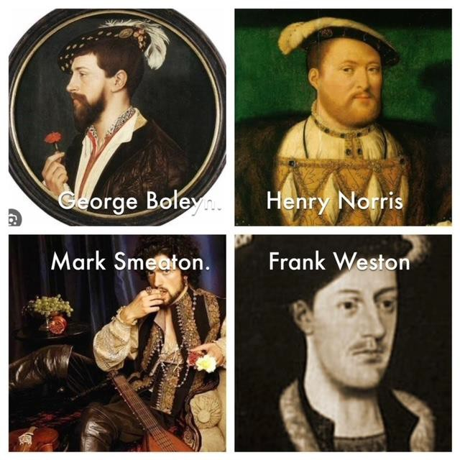

THE PLAY READING AND ACKNOWLEDGMENTS
Unlike many of the famous State Trials, there is no transcript of the trial of Queen Anne. What will be seen and heard in the play reading is an imaginative reconstruction, designed to tell the tale and with a fair degree of dramatic licence. Once again, the play reading will be presented in verse. It is hoped that this will not distract from the serious issues considered.
In writing the play, I have referred to, and much enjoyed, the history contained in the book, Bring up the Bodies, written by Hilary Mantel. Some of the words, thoughts and nuances attributed to the players’ characters are taken directly from the author. Others have arisen in my mind only. There have been some interesting TV series also in recent years, describing the same events as I cobble together here. I have also read and enjoyed a legal paper, Law as the Engine of State: the Trial of Anne Boleyn, by Ms & F Schauer (William and Mary Law Review [Vol. 22:49])

My friend, Trish Smith, of the NT Office of the Director of Public Prosecutions [with the Director’s approval, and the assistance of Kylie Green], has once again reduced this Introduction and the play reading script to manageable documents. She has prepared copies of the Introduction which will have been distributed to delegates and their friends at the Conference. I am grateful to each of those named.

As I usually do, I now thank the President and the Committee of CLANT for this further opportunity to participate in the affairs of the Conference, maintaining my association and friendship with my former, and new, colleagues. Might I particularly mention my delight in the fact that my daughter, Beth Wild, is now continuing a family interest in CLANT, the Conference and the NT criminal law. I also include a further personal note. This appeared in the introduction to the play presented in 2022:

This is the first conference I will be attending without my wife and best friend, Lyn. Others will probably speak of her and the remarkable organisation of 13 conferences from 1995 to 2019 and her general contribution to the affairs of CLANT – she was a Life Member, too. My personal loss will be obvious to you all.

Obviously enough, this will be the first Bali Conference at which Lyn has not appeared at either the Hotel Reception desk or Registration site to greet delegates. I wish Abi Rajkumar and CLANT success in this year’s Conference, which I anticipate will be an excellent event.

Finally, I thank the players who have, mostly, volunteered their services. I expect they will enjoy this particular performance as much as any that have preceded it. Their names, without any honorifics, are listed somewhere amongst these papers. Thank you, in anticipation, also to the Delegates and their family and friends for participating in the proceedings!

REX WILD
Darwin, NT [Sanur, Bali, at time of notional signing] 23 June 2024

∗ The plays are listed on the CLANT website. The original introductions are there available, together in many cases with the play reading script.

THE TRIAL OF ANNE BOLEYN
How Annie lost her head to Hal

CLANT 2024

Dramatis Personae and Players
Queen Elizabeth 1 [Commentator & Historian] Belinda Lonsdale Narrator [Thomas Howard, the Duke Tom Percy
of Norfolk, Lord High Steward]
Henry VIII Grant Algie
Mary Boleyn Abi Rajkumar
Thomas Cromwell [“Crum”], King’s Chief Adviser Lloyd Babb Thomas Cranmer, Archbishop of Canterbury Richard Coates Catherine of Aragon Elizabeth Morris
Anne Boleyn Peggy Dwyer

Queen Anne’s courtiers
Henry Norris Gabriel Chipkin
George Boleyn, Earl of Rochford Ambrith Abayasekara
Jane, Lady Rochford Annmarie Lumsden
Mark Smeaton Emrys Nevkabil
Elizabeth, Lady Worcester Suzan Cox
Francis Weston James Stuchbery
Jane Seymour Beth Wild
Lady Anne Boleyn [Anne’s Aunty] Anne Healey
Cromwell’s Servant, Christophe Simon O’Halloran

Jury
Jenny Blokland
Sue Phoo Rosie Phoo
Rufus Abayasekara Edward Wild Hubber Brooke Houen
Sue Oliver
Best Boy Ian Read

